

# *Project Report*

# *on*

**“Software Development Project Management Plan for Bangladesh Railway automated ticket issuing system.”**

**Prepared By**

|  |  |  |
| --- | --- | --- |
| **ID** | **Name** | **Date and Signature** |
| **15-30352-2** | **Ahamed Faisal** |  |
| **15-30370-2** | **Lodi Rafi Khan** |  |
| **15-30389-2** | **Milon Md. Mahafuzur Rahman** |  |
| **15-28316-1** | **Treena Farzana Islam** |  |
| **15-28280-1** | **Arafat MD Omer** |  |

**Course Name:** **Software Development Project Management (SDPM).**

**Section:** A

FACULTY OF SCIENCE & INFORMATION TECHNOLOGY

AMERICAN INTERNATIONAL UNIVERSITY BANGLADESH (AIUB)

|  |
| --- |
|  |

**Supervised By**

**S.M. ABDUR BHUIYAN ROUF**

**Assistant Professor**  
FACULTY OF SCIENCE & INFORMATION TECHNOLOGY

AMERICAN INTERNATIONAL UNIVERSITY BANGLADESH (AIUB)

**Contents**



1. **Title Page…….………………………………………………………………………………..……1**
2. **Revision History Page……………………………………………………………………..3**
3. **Introduction……………………………………………………………………………………….4**
4. **Process Model…………………………………………………………………................4**
   1. **Software Model………………………………………………………………………..4**
   2. **Reason of choosing this model……………………………………………..5**
   3. **Software Life Cycle Flow Chart……………………………………………..5**
5. **Quality gate for each phase of software development………………..…6**
6. **List of tasks…………………………………………………………………………………….....6**
7. **WBS …………………………………………………………………………………………………..7**
8. **Project Estimation………………………………………………………………………………8**
9. **Estimation for each task…………………………………………………………………9**
10. **Schedule the tasks…………………………………………………………………………....9**
11. **Prepare list of milestones………………………………………………………………...10**
12. **Staffing Plan…………………………………………………………………………………….10**
    1. **Role Requirements………………………………………………………………….11**
    2. **Staff Assigned To Roles…………………………………………………………..11**
    3. **Staff Resources Loading Chart………………………………………………..12**
13. **Monitoring and Controlling Mechanism ………………………………………13**
14. **Risk Management……………………………………………………………………………14**
15. **List of Deliverables………………………………………………………………………….16**
16. **Defect Tracking Process………………………………………………………………….18**
17. **Metrics…………………………………………………………………………………………..21**
18. **Postmortem……………………………………………………………………………………22**

**Revision History**



|  |  |  |  |
| --- | --- | --- | --- |
| ***Revision*** | ***Date*** | ***Authors*** | ***Description*** |
| **Version 1.0.0.0** | **April 16, 2018** | **Treena Farzana Islam,**  **Lodi Rafi Khan,**  **Arafat MD Omer ,**  **Milon Md. Mahafuzur Rahman ,**  **Ahamed Faisal** | **First Version** |

**Introduction**



This document addresses the requirements for automated ticket issuing system of Bangladesh Railway. The system support menu selection using touch screen. The ideal audience for this document is the designers and the Bangladesh Railway System (BRS) of the project. It is the controlling document for this project. It specifies the technical and managerial approaches to develop the software product. As such it is the companion document to Requirements Analysis Document (RAD). Changes in either may imply changes in the other document. All technical and managerial activities required to turn over the deliverables to the BRS are included. This includes scheduling, identification of tasks, and factors that may impact the project and planning.

**Process Model**



**Software Model**

Rapid Application Development (RAD) is a software development methodology that focuses on building applications in a very short amount of time; traditionally with compromises with usability, features and execution speed. This methodology gathers customer requirements through workshops or focus groups, early testing of the prototype by the customer using iterative concept, reuse of the existing prototypes, continuous integration and rapid delivery. The term generally describes applications that can be designed and developed within 60-90 days. The important aspect for this model to be successful is to make sure that the prototype developed is reusable.

**Reasons of choosing this model**

1. Changing requirements can be accommodated.
2. Progress can be measured.
3. Encourages customer feedback.
4. Increases reusability of components.
5. Prevents cost overruns.
6. Prevents runaway schedules (RAD needs a team already disciplined in time management)
7. To save development time, possibly at expense of economy or product quality
8. The business requirements for a system can be fully satisfied even if some of its operational requirements are not satisfied. The acceptability of a system can be assessed against the agreed minimum useful set of requirements rather than all requirements.

**Software Life Cycle Flow Chart**

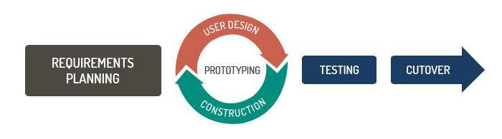

**Quality Gates for Each phase of SW Development**



Increased quality is a primary focus of the Rapid Application Development methodology, but the term has a different meaning than is traditionally associated with Custom Application development. In case of RAD quality in development was both the degree to which an application conforms to specifications and a lack of defects once the application delivered. According to RAD quality is defined as both the degree to which a delivered application meets the needs of users as well as the degree to which a delivered system has low maintenance costs. RAD attempts to deliver on quality through the heavy involving of users in the analysis and particularly the design stages.

**List of Task:**

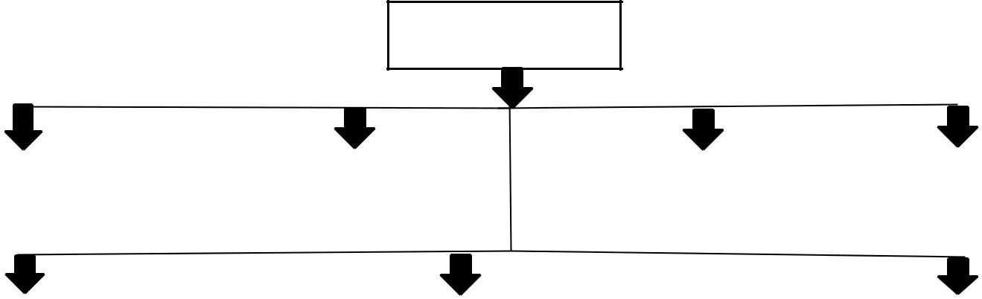

**1.0 Project**

|  |  |  |  |  |  |  |  |
| --- | --- | --- | --- | --- | --- | --- | --- |
| System Desig |  |  |  |  |  |  |  |
|  | **1.0.2 Project** |  | **1.0.3 Requirements** |  | **1.0.4 Object Design** |  |
| **1.0.1 Requirements** |  |  |  |  |  |
| **Elicitation** |  | **Planning** |  | **Analysis** |  |  |  |
|  |  |  |  |  |  |  |  |
|  |  |  |  |  |  |  |  |
|  |  |  |  |  |  |  |  |

|  |  |  |  |  |
| --- | --- | --- | --- | --- |
| **1.0.5 System Design** |  | **1.0.6 Implementation & Unit Testing** |  | **1.0.7 System Integration & System Testing** |
|  |  |  |  |  |

|  |  |
| --- | --- |
| **Task** | **Quality Assurance method** |
| SDPM Planning | Word spell checker & formal review |
| Requirement document | Word spell checker & formal review |
| Design document | Word spell checker & formal review |
| Code | Code inspection and testing |
| Alpha Testing | 3 week testing on developer site |
| Beta Testing | 3 week testing on client site |

**WBS (Work Breakdown Structure)**

1. Initialization.

1. Planning.
2. Designing.
3. Implementation

a) Coding

b) Database

5. Testing

a) Unit Testing

b) Integration Testing

c) System Testing

d) Performance Testing

1. First Release
2. Maintenance.

7. Death

**Project Estimation:**

We Know,

Effort = PM = Coefficient<EffortFactor>*(SLOC/1000)^P

Development Time = DM = 2.50*(PM)^T

Required Number of people = ST = Effort(PM)/Development Time(DM)

where:  
PM : person-months needed for project  
SLOC : source lines of code  
P : project complexity (1.04-1.24) [we take 1.04 for this project]  
DM : duration time in months for project  
T : SLOC-dependent coefficient (0.32-0.38)[we take 0.32 for this project]  
ST : average staffing necessary

We know for semidetached project

Coefficient =3.0

P=1.04

T=0.32

Let,

SLOC = 8500

Than,

Effort =PM=3.0*(8500/1000)^1.04=28 person month

DM=2.50*(0.23)^0.32=2 month

ST=28/2=13 person

**Estimation for each task:**



|  |  |  |
| --- | --- | --- |
| **Task Of Phase** | **Days** | **Hours** |
| Requirements Elicitation | 28 | 224 |
| Project Planning | 14 | 112 |
| Requirements Analysis | 14 | 112 |
| System Design | 14 | 112 |
| Object Design | 14 | 112 |
| Implementation & Unit Testing | 21 | 168 |
| System Integration & System Testing | 21 | 168 |

* Total days are 126 days and working hour is 1008 hour.

**Schedule the Task**

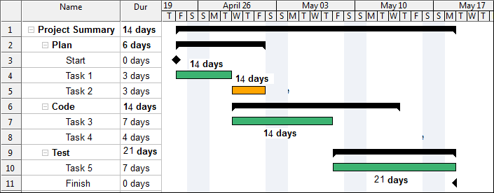

|  |
| --- |
| **List of Milestone** |



|  |  |
| --- | --- |
| **Date** | **Project Milestones** |
| January 2 ,2019 | Project presentation by Bangladesh Railway Systems |
| January 9, 2019 | Analysis Review |
| January 16, 2019 | Project Review with Bangladesh Railway Systems |
| January 30, 2019 | Code Design Review |
| February 14, 2019 | Internal Project Review |
| March 01, 2019 | Project Acceptance by Bangladesh Railway Systems |

**Staffing Plan**



The purpose staffing plan is to make certain the project has sufficient staff with the right skills and experience to ensure a successful project completion.

**Role Requirements**

The following is a detailed breakdown of the roles required to execute the project. It includes the project role, the project responsibility of the role, skills required, number of staff required fulfilling the role, the estimated start date and the expected duration the staff resource will be needed on the project.

|  |  |  |  |  |  |
| --- | --- | --- | --- | --- | --- |
| **Role** | **Project Responsibility** | **Skill Required** | **No of Staff** | **Estimated Date** | **Duration** |
| Project Manager | Completing the project within due time, budget and quality | Leadership, Communication, Organizational, Problem Solving etc | 1 | 20 December 2018 | 2 weeks |
| Requirements Analyst | analyze, validate, specify, verify, and manage the real needs of the project stakeholders, including customers and end users | Communication, problem-solving, and critical thinking skills. | 2 | 9 January 2019 | 2 weeks |
| Java Developer | Java Development | OOP in Java | 4 | 23 January 2019 | 2 weeks |
| Web Developer | Front end and backend design | HTML, CSS, Bootstrap,  JavaScript, PHP etc | 4 | 30 January 2019 | 2 weeks |
| Software Engineer | Software Quality and testing | Strong knowledge in capability Maturity Model Integration(CMMI) | 2 | 21 February 2019 | 3 weeks |

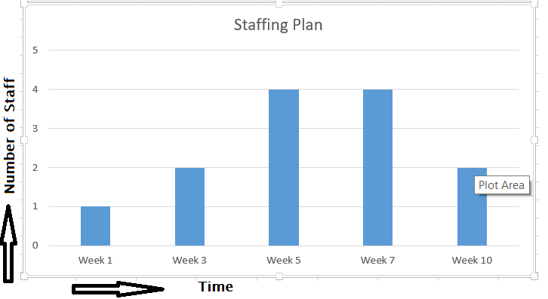

|  |  |  |
| --- | --- | --- |
| **Person** | **Assignment** | **Backup** |
| Faisal Ahamed | Project Manager | Omer Khaiyum |
| Rubel Hasan, Amir Khushru | Requirements Analyst | Himel Mahmud |
| Shahadat Hossain,Ashifur Rahaman, Labib Ittehadul,Shohag DX | Java Developer | Shakhawat Hossain, Tamanna Haq,Shohel Rana, Adil Hossain |
| Hossain Arif, Babu Hossain, Duke Rahman,Shuvo Hossain | Front-End and Backend Developer | Rayhan Hossain,Arif Hossain,Asfia Akter,Abu Hayder |
| Abu Hayder Rony | Quality Analyst | Nazmul Huda |

**Monitoring & Controlling Mechanism**



Following list of mechanisms is followed to track the schedule-

* Prescribe the reporting mechanisms, report formats, review and audit mechanisms, and so on such as other tools and techniques to be used in monitoring and controlling the project.
* Project monitoring should occur at the level of work packages. Include monitoring and controlling mechanisms for the project support functions (quality assurance, configuration management, documentation and training).
* A table may be used to show the reporting and communication plan for the project.
* Weekly Project status meeting with team members.
* Question and Answer activities are executed as planned.
* EVA(Earn value analysis) report is used to analysis the progress quantitatively.

R**isk Management**



Here, this section mentions not only a number of possible risks for the project but also actions or measures are described to prevent or to reduce the risks.

|  |  |  |  |
| --- | --- | --- | --- |
| Risk Id : Risk -1 | Date : | Probability : 60% | Impact:Midium |
| **Description** : Software team does not have good experience in distributed DBMS. | | | |
| **Mitigation Plan** : Organize 4 day training program and build a prototype distributed database. | | | |
| **Monitoring &Management** : Track progress of the developers on weekly basis until the team is confidently tested the prototype. | | | |
| **Status** : Initial Identification | | | |

|  |  |  |  |
| --- | --- | --- | --- |
| Risk Id : Risk -2 | Date : | Probability : 65% | Impact:High |
| **Description** : Risk with respect to staff turnover. | | | |
| **Mitigation Plan :** Improve working environment, increase salary; Monitor the team member’s general attitude; Assign backup team member. | | | |
| **Monitoring &Management** : Ensure that working environment are improved and backup members are available. | | | |
| Status : Initial Identification | | | |

|  |  |  |  |
| --- | --- | --- | --- |
| Risk Id : Risk -3 | Date : | Probability : 20% | Impact: Low |
| **Description** : Risks with respect to the customer. | | | |
| **Mitigation Plan :** Focus on the agreed user requirements, which express the wishes of the customer. | | | |
| **Monitoring &Management** : Ensure that customer requirements are full filled. | | | |
| **Status** : Initial Identification | | | |

**LIST OF DELIVERABLES:**



This System documentation basically explains the principles of operation. The delivery consists of a presentation of the system, a demonstration of the working system and the successful passing of the acceptance test. Bangladesh Railway System expects the acceptance test to be successfully demonstrated remotely via the Internet April 14, 2019 from 10:30 am to 1.30pm. All work deliverables will be on April 14, 2019.

**Deliverable work products:**

|  |  |  |  |  |
| --- | --- | --- | --- | --- |
| **Name** | **Preparer** | **Reviewer** | **Date** | **Distribution List** |
| Software Design  specification | IEEE 1063-2001 | Project  manager | January  9,2019 | Reviewer, PM,  Consultant 1,  Programmer1,Technical writer |
| End-user  documentation | Technical  writer 1 | Consultant  2 | February  24,2019 | Reviewer,  PM,  Document  expository |
| Software | Requirements | Requirements | March  1,2019 |  |
| Software  project  management plan | Project  Manager | Bangladesh Railway  committee | January 2  2019 | Document  repository,  Preparer,  PM, |
| Software  quality  assurance  plan | Quality  analyst | Project  Manager | March  25,2019 | Reviewer ,PM |

**Non -deliverable work products:**

|  |  |  |  |  |  |
| --- | --- | --- | --- | --- | --- |
| **Name** | **Standard** | **Preparer** | **Reviewer** | **Review** | **Distribution** |
|  |  |  |  | **due** | **List** |
| Project team | Meeting | Project | Meeting | 24 | Reviewer, |
| meeting | minutes | Manager | participants | hours | Document |
| minutes | template |  |  | after | repository |
|  |  |  |  | meeting |  |
| Design | Technical | Software | review | 72 | Reviewer, |
| review | Agenda | Designer | participants | hours | Document |
| summaries | template |  |  | prior to | repository |
|  |  |  |  | review |  |
| project | quality | quality | Meeting | N/A | Document |
| Project team | Meeting | Project | Meeting | 24 | Document |
| meeting | Agenda | Manager | participants | hours | repository , |
| agendas | template |  |  |  | Reviewer |

**DEFECT TRACKING PROCESSES:**



This document is details of process to bug or defect follows. It also details the way in which a bug or defect is entered in to the bug tracking database.

**Process of defect tracking:**

1. Open Defects using bug or defect template and bug tracking software.
2. The Defect is being addressed by the developer and investigation is under progress.
3. The Defect is being addressed by the developer and investigation is under progress. At this stage there are two possible outcomes, like: Deferred or Rejected.
4. When the defect is NOT fixed, QA reopens/reactivates the defect.
5. A defect can be rejected for any of the 3 reasons; Duplicate defect, not a Defect, Non Reproducible.
6. When a defect cannot be addressed in that particular cycle it is

Deferred to future release.

1. The Defect is fixed and ready for testing.
2. The Defect that is retested and the test have been verified by QA.
3. The final state of the defect that can be closed after the QA retesting or can be closed if the defect is duplicate or considered as NOT a defect.

**Defect Life Cycle Process:**

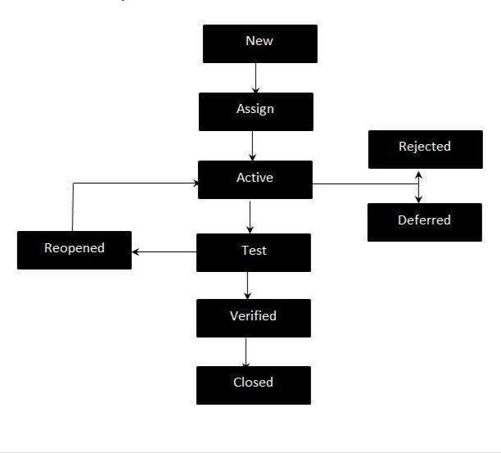

|  |  |  |
| --- | --- | --- |
| **Priority Level** | **Description** | **Response Time** |
|  |  |  |
| High | A defect occurred in | Defect should be |
|  | credit transaction. Some | responded to |
|  | users complain that | administration and also |
|  | sometimes the system | developers to handle the |
|  | show transaction error | situation within 24 hours. |
|  | instead of valid credit |  |
|  | card. This problem causes |  |
|  | a major functional |  |
|  | problem. |  |
| Medium | A defect occurred due to | Defect should be |
|  | multiple train ticket | responded by developers |
|  | purchasing. This problem | within 2 working days. |
|  | cause the system too |  |
|  | much delay and slow. |  |
| Low | A defect occurred in | A response action plan |
|  | keyboard system. This | should be provided within |
|  | problem cause a little bit | 5 working days and |
|  | uncomfortable user to | should be resolved before |
|  | use that system. | test exit. |

**Metrics:**



|  |  |  |
| --- | --- | --- |
| **Metrics** | **Description** | **Tracking** |
|  |  | **Tool** |
|  |  |  |
| Schedule | Milestones | MS Project |
|  |  |  |
| Staff Usage | Graph of person used per month | MS Excel |
|  | Both projected and actual |  |
|  |  |  |
| Expenditures | Graph of total expenditures over | MS Excel |
|  | time |  |
|  | Both Projected actual |  |
| No. of Requirements | Graph of total requirements | MS Excel |
|  | Identified per module over time |  |
|  |  |  |
| No. of Requirements | Graph of number of defects | MS Excel |
| Defects | identified per module over time |  |
|  |  |  |
| No. of Objects | Graph of number of objects | MS Excel |
|  | identified over time |  |
|  |  |  |
| Coding Progress | Number of objects coded | MS Excel |
|  |  |  |
| Coding Size | Lines of code measured daily | MS Excel |
|  |  |  |
| Test Progress | Unit test causes passed over | MS Excel |
|  | time |  |
| Defect Tracking | Number of codes defects | MS Excel |
|  |  |  |
| Test Progress | Number of integration test | MS Excel |
|  | Passes over time |  |
|  |  |  |
| Defect Tracking | Number of code defects test | MS Excel |
|  | Passed over time |  |
|  |  |  |

**Postmortem**



The entire project plan follows the model, a modified RAD model. Three prototypes have to be delivered: A graphical user interface, a functional prototype and a system integration prototype. Analysis is started after Project Planning is finished. System Design is followed by Code Design. Important Milestones are the Analysis Review March 9-14, the Project Status on March 14, the Project Review on March 28 and the Code Design Review on April 5. Implementation and Unit Testing are scheduled to overlap significantly. System Integration is scheduled to immediately follow Unit Testing. System Testing starts immediately after system integration and leads to the Bangladesh Railway automated ticket issuing Systems Acceptance Test on April 23, 2019.



**2018 © Rafi,Arafat,Treena,Milon,Faisal**